范例执行结果及测试情况说明

DATA 1（没有规定经过城市的最小费用策略）

SET 0:00 BEIJING

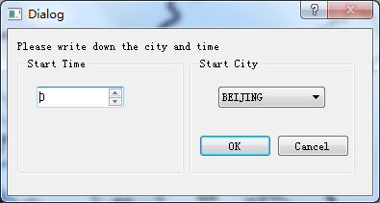

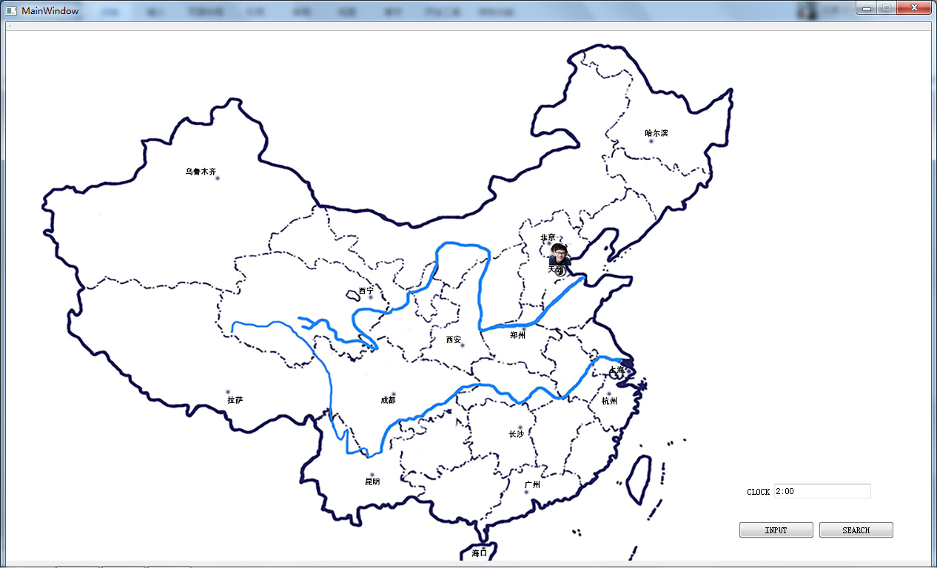

INPUT TIME 05:00 TOURIST ID 0 DESTINATION WULUMUQI STRATEGY MINICOST MIDCITY EMPTY

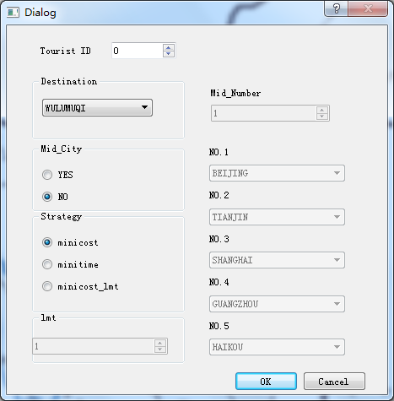

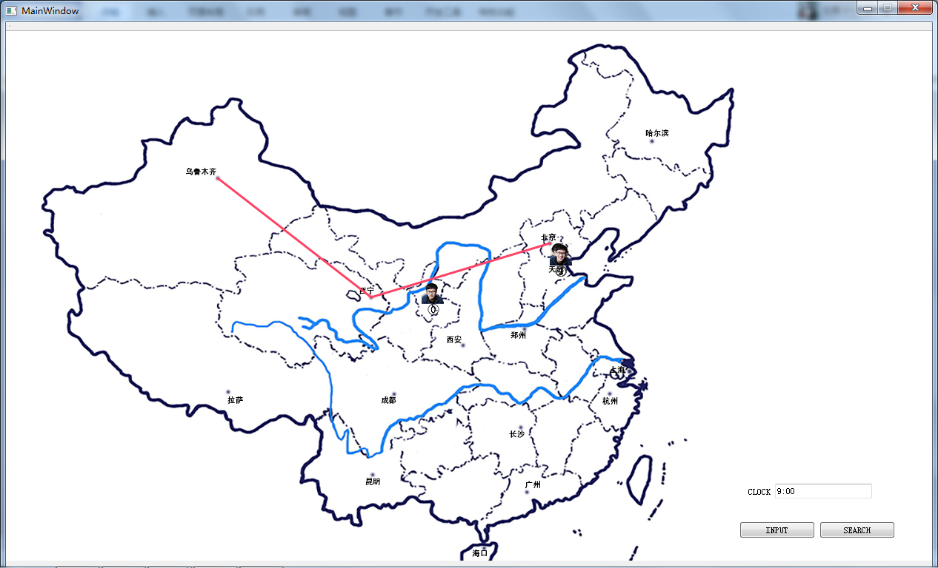

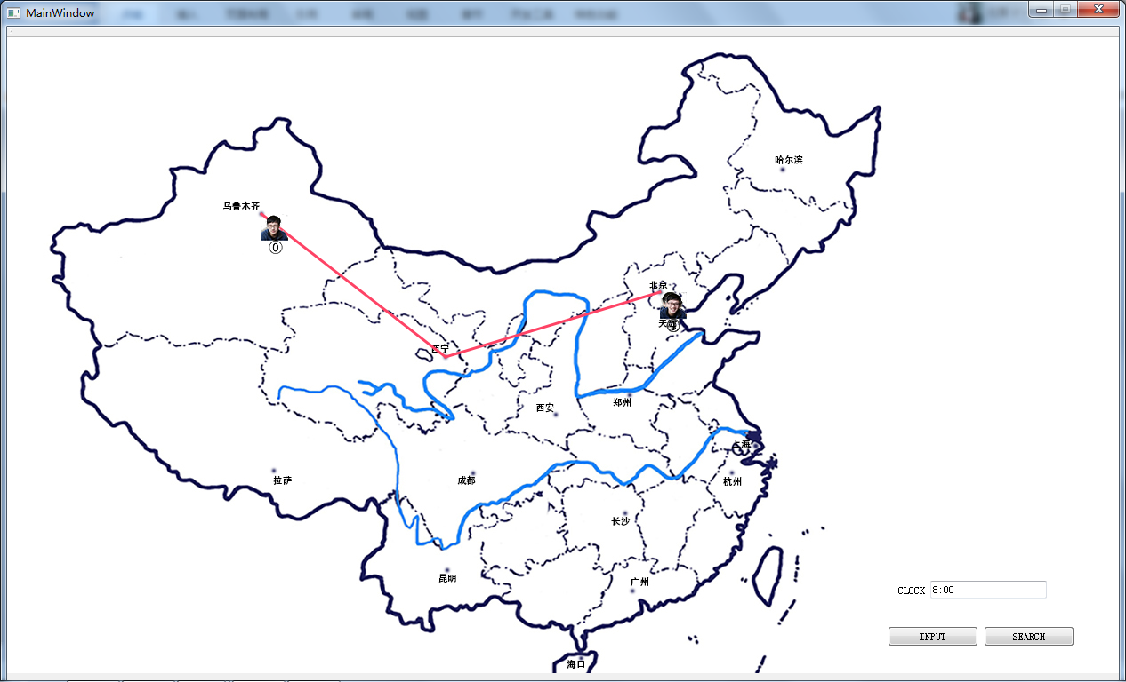

SEARCH TIME 05:00 TOURIST ID 0

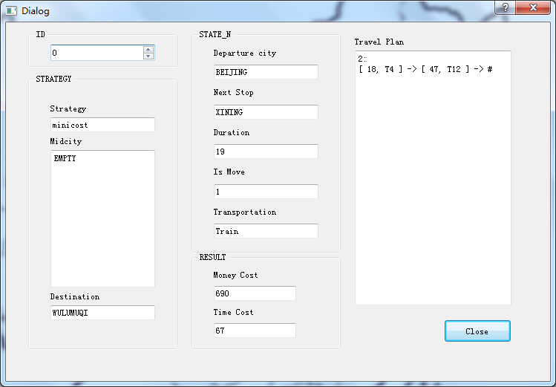

SEARCH TIME 17:00 TOURIST ID 0

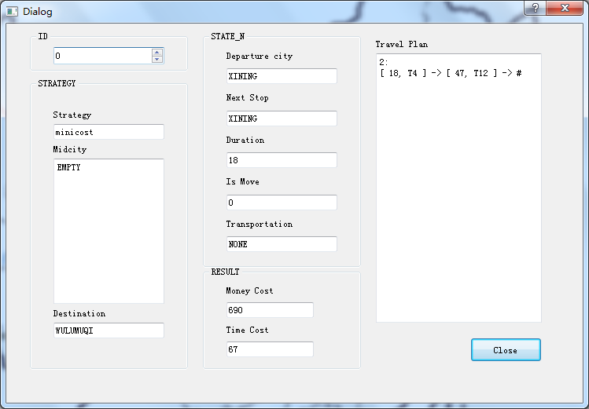

SEARCH TIME 4:00 TOURIST ID 0

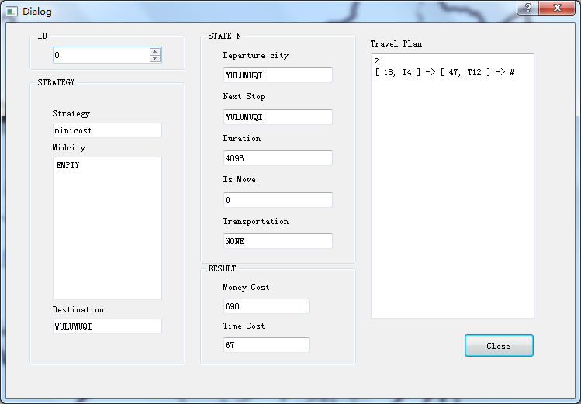

DATA2（没有经过城市的最小时间策略）

SET 05:00 SHANGHAI

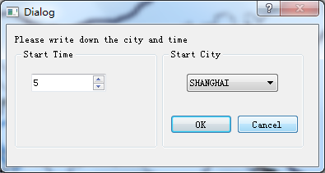

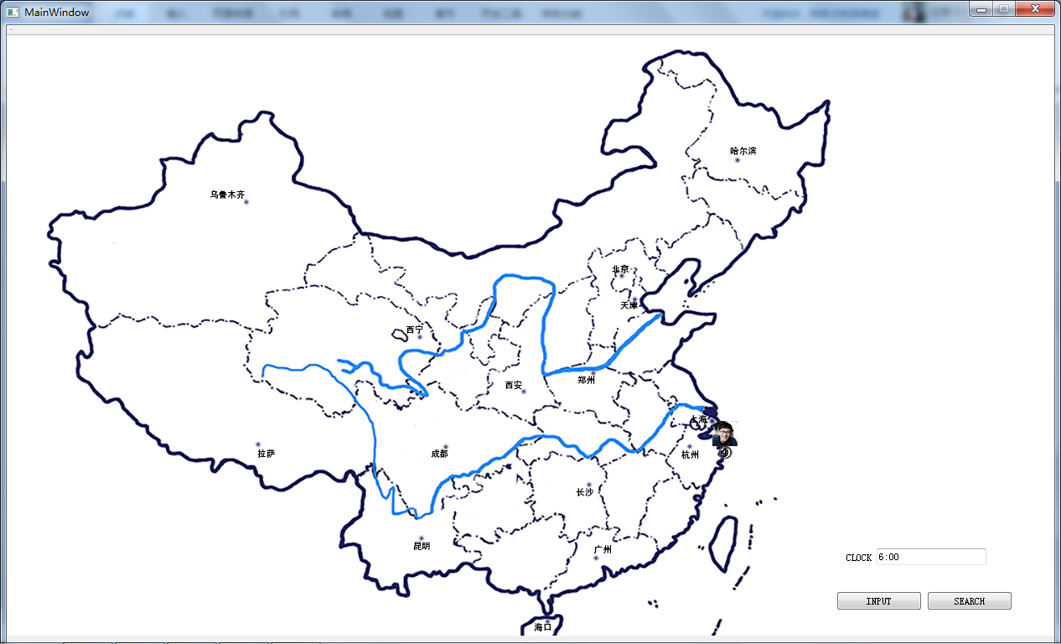

INPUT TIME 06:00 TOURIST ID 0 DESTINATION WULUMUQI STRATEGY MINITIME MIDCITY EMPTY

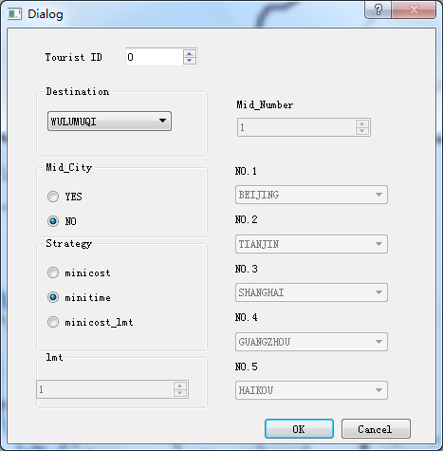

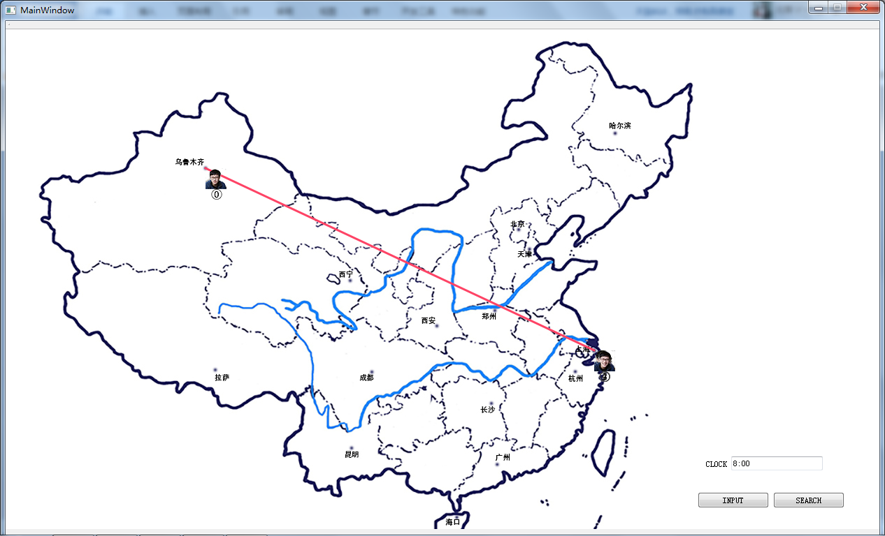

SEARCH TIME 20:00 TOURIST ID 0

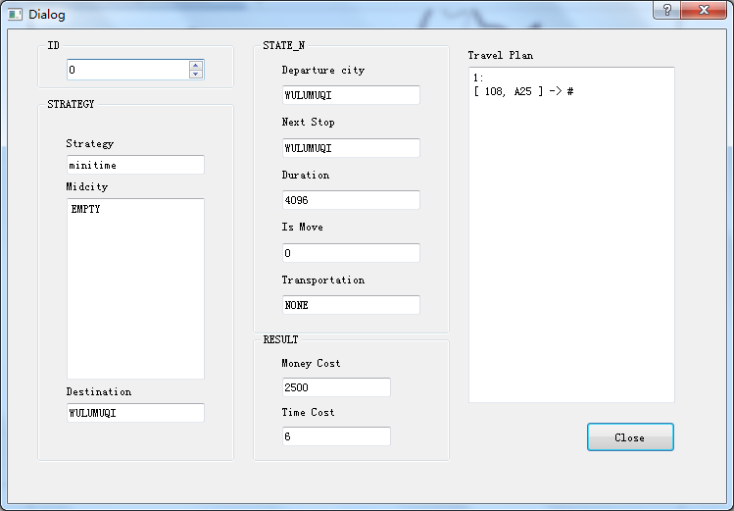

DATA 3（没有规定经过城市的限制时间最小费用策略）

SET 00:00 HAERBIN

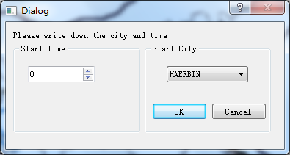

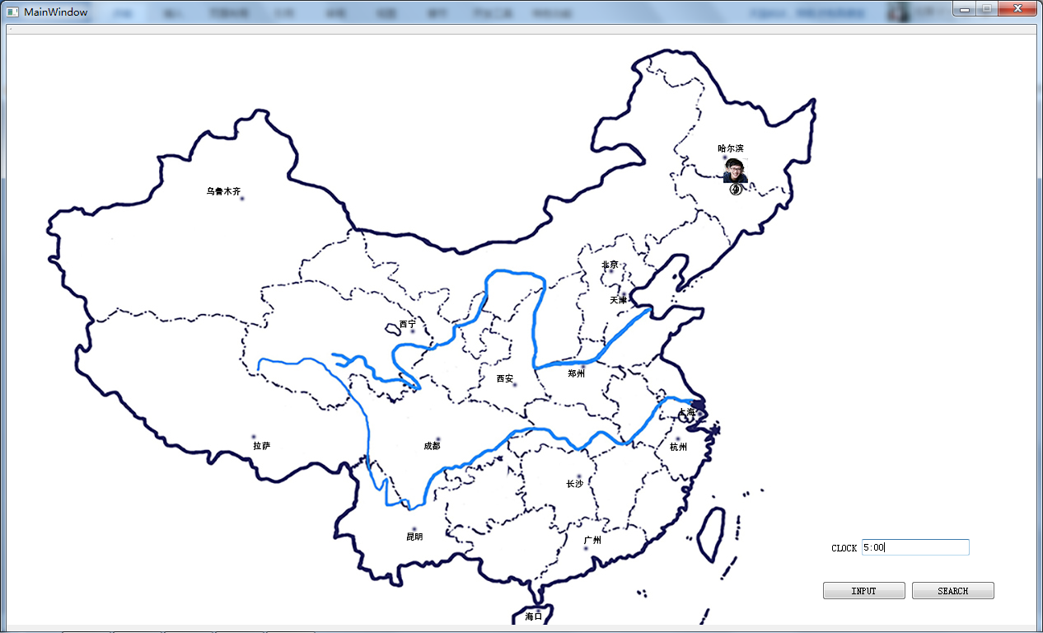

INPUT TIME 05:00 TOURIST ID 0 DESTINATION KUNMING STRATEGY MINICOST_LMT:50 MIDCITY EMPTY

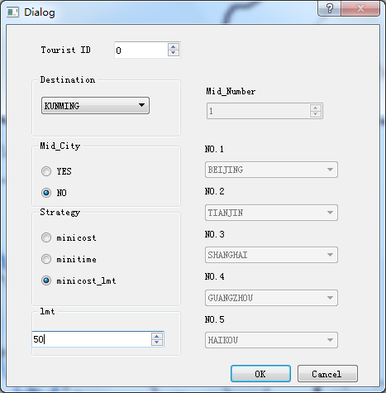

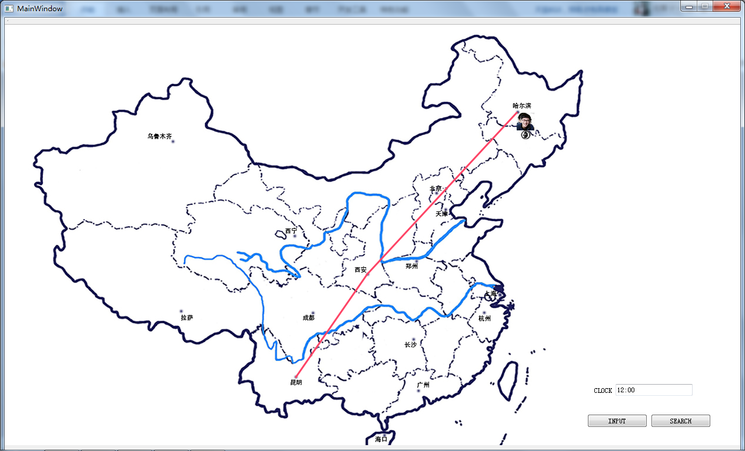

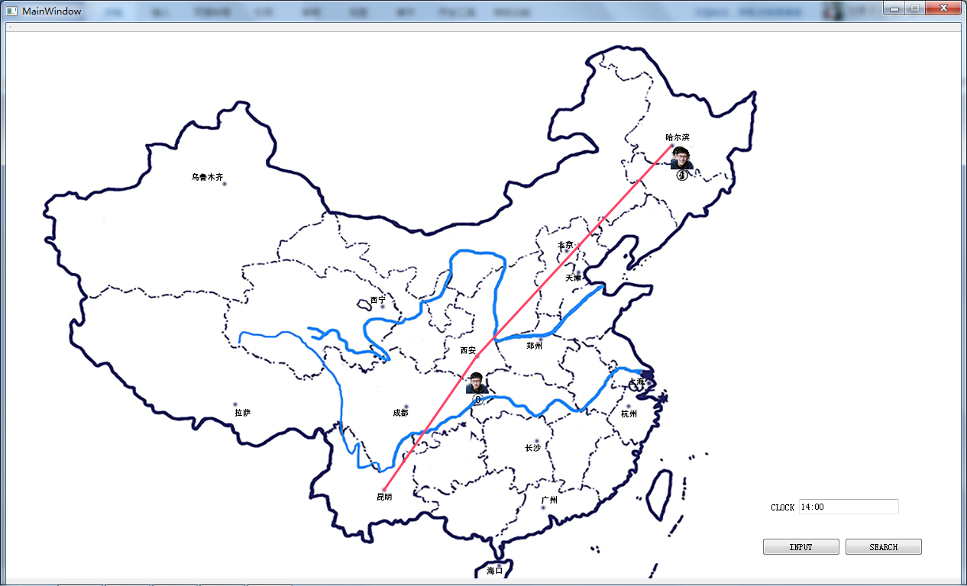

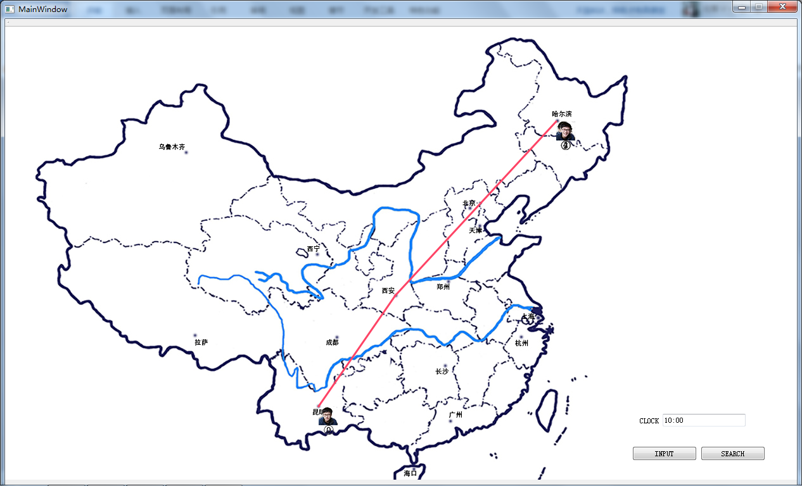

SEARCH TIME 17:00 TOURIST ID 0

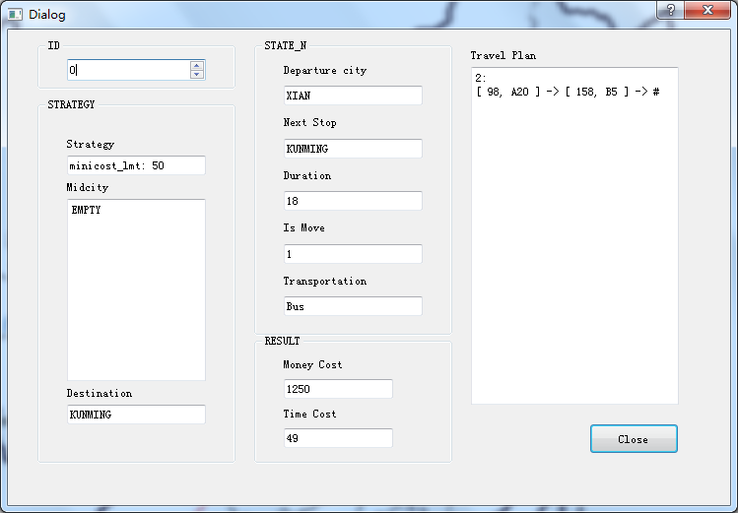

DATA 4（有规定经过城市的最小费用策略）

SET 00:00 HAERBIN

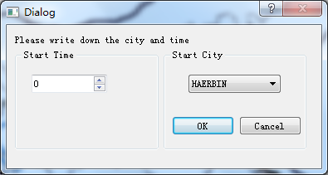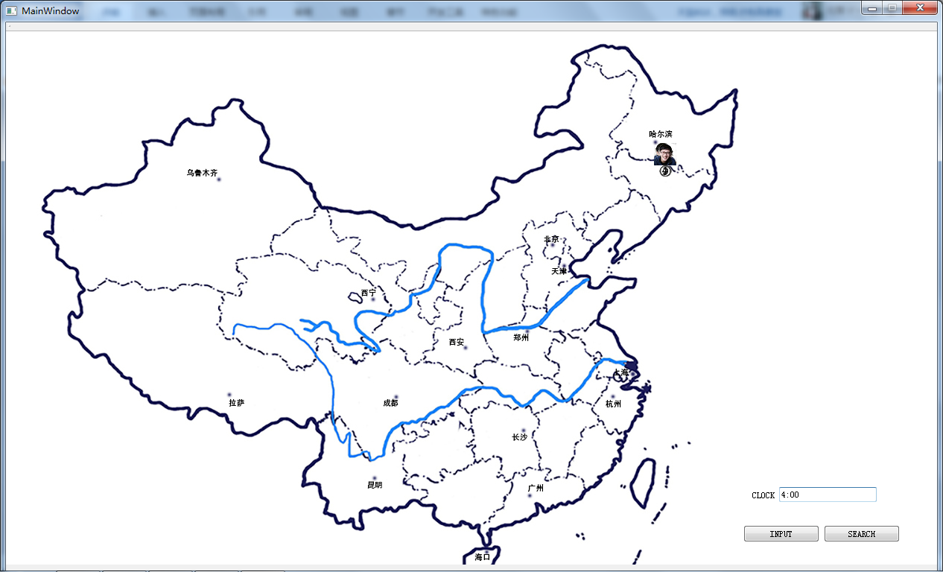

INPUT TIME 05:00 TOURIST ID 0 DESTINATION LASA STRATEGY MINICOST MIDCITY XIAN CHENGDU

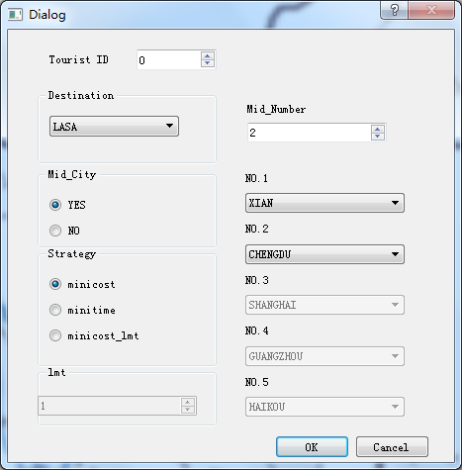

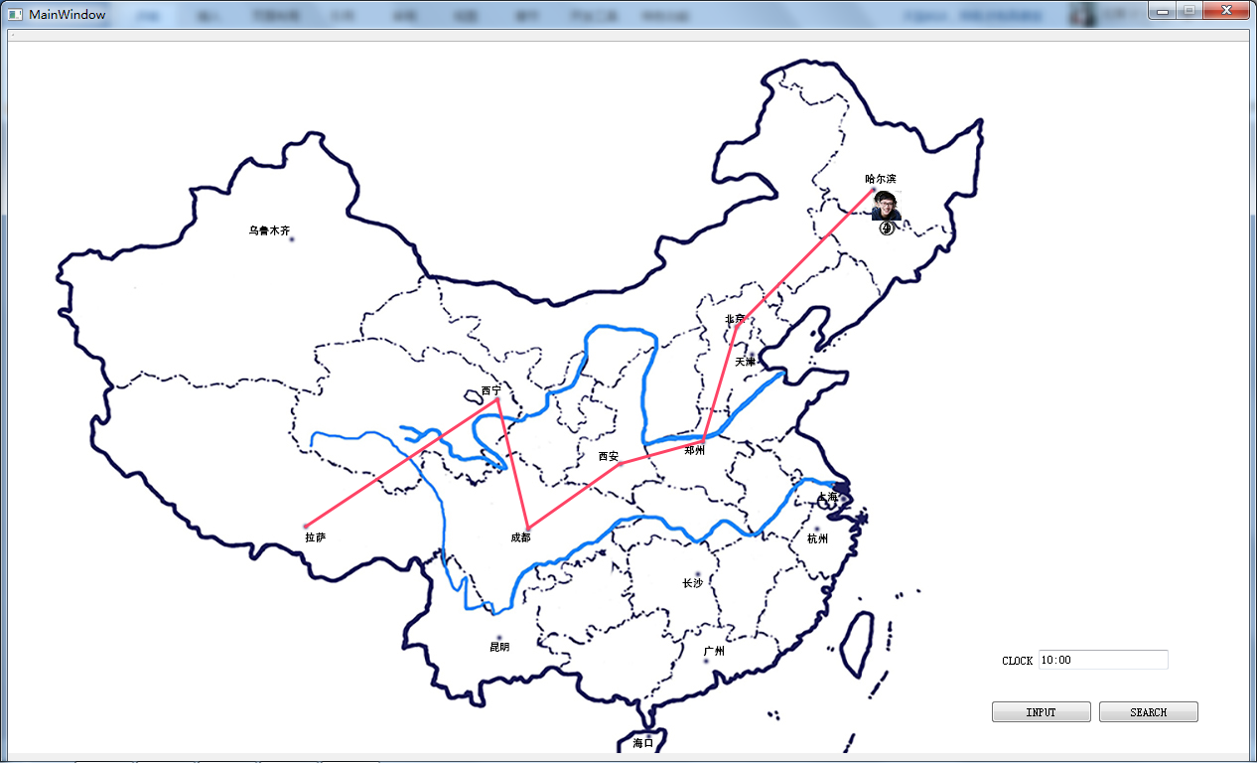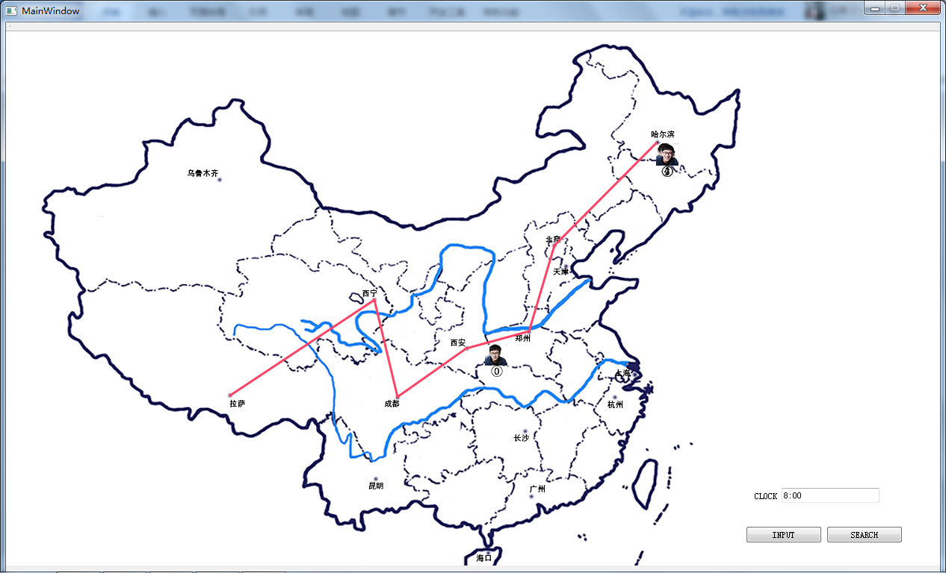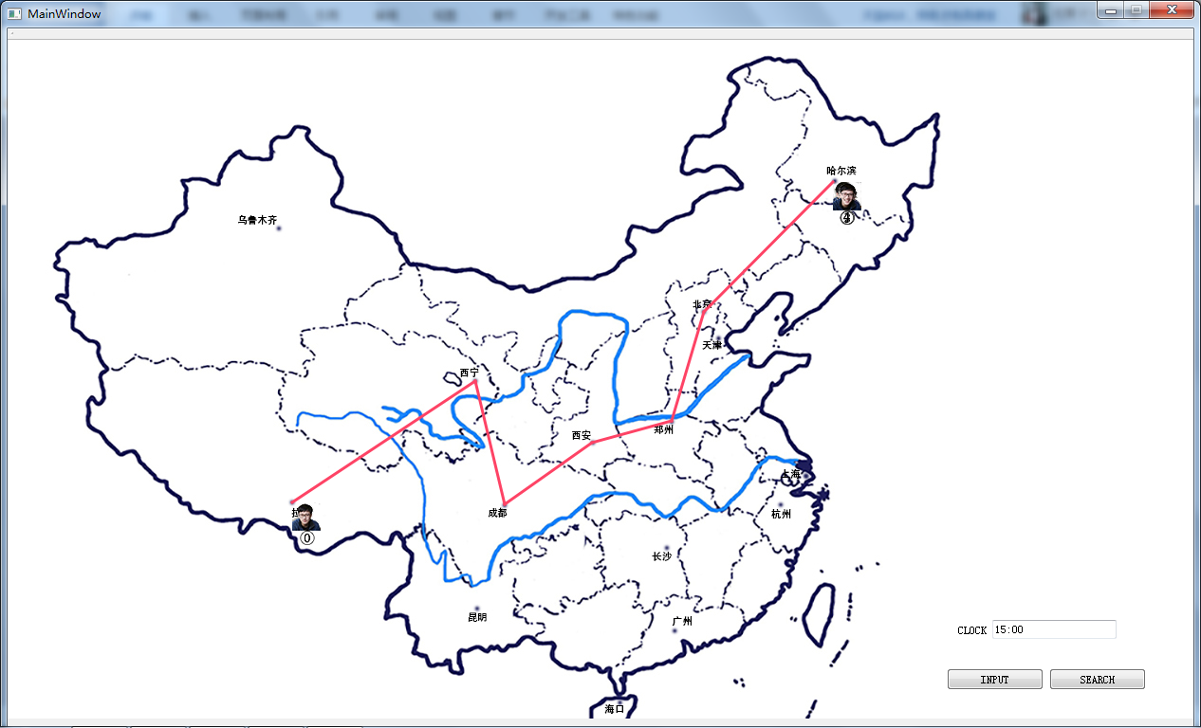

SEARCH TIME 23:00 TOURIST ID 0

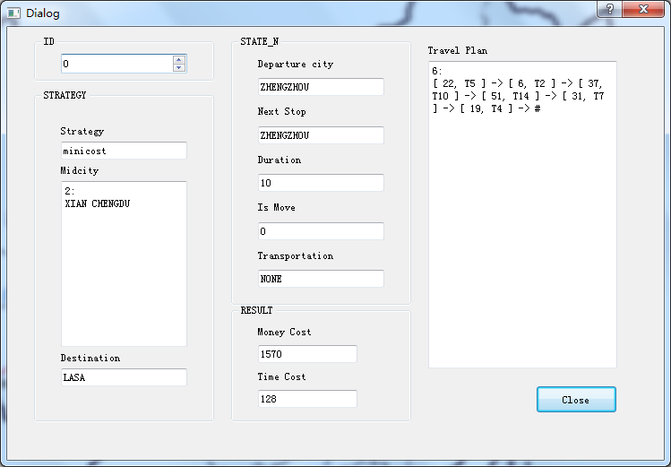

DATA 5（有规定经过城市的最小时间策略）

SET 00:00 BEIJING





INPUT TIME 03:00 TOURIST ID 0 DESTINATION GUANGZHOU STRATEGY MINITIME MIDCITY XIAN SHANGHAI

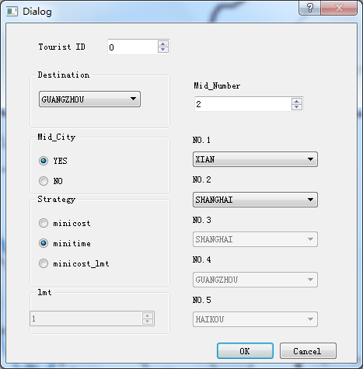

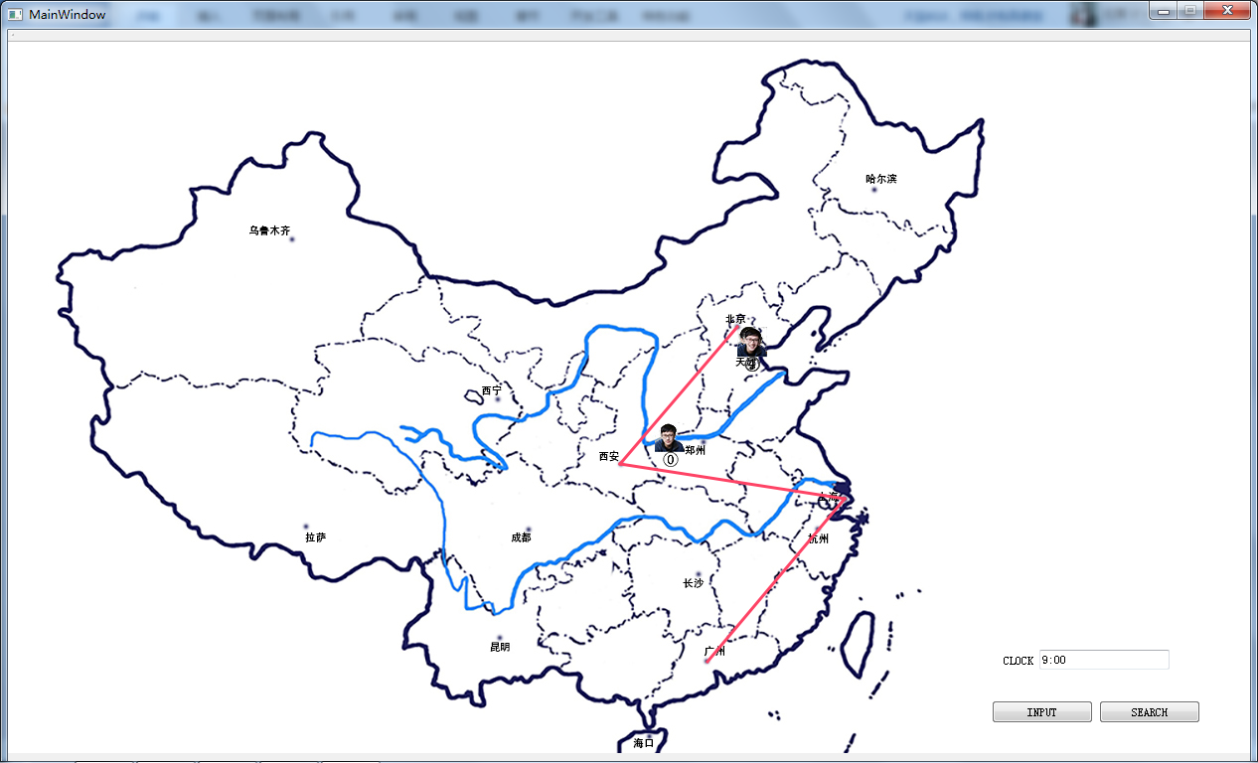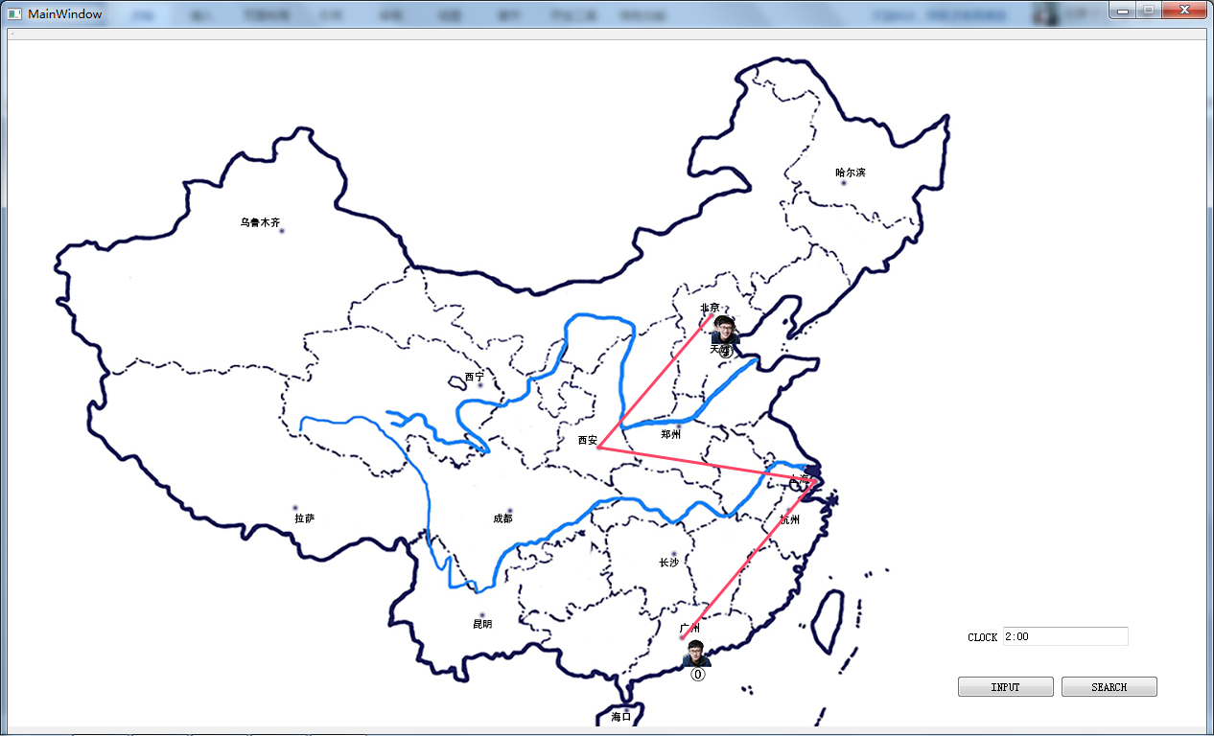

SEARCH TIME 22:00 TOURIST ID 0

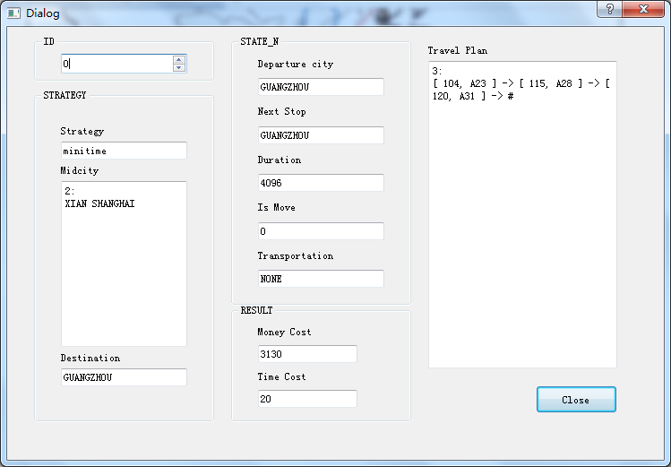

DATA 6（有规定经过城市的限制时间最小费用策略）

SET 00:00 BEIJING



INPUT TIME 06:00 TOURIST ID 0 DESTINATION KUNMING STRATEGY MINICOST_LMT:60 MIDCITY ZHENGZHOU CHANGSHA

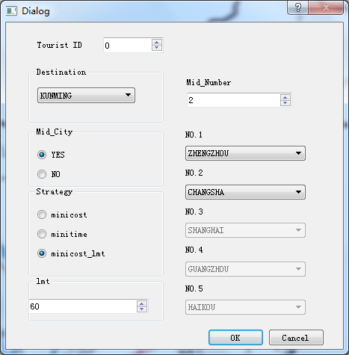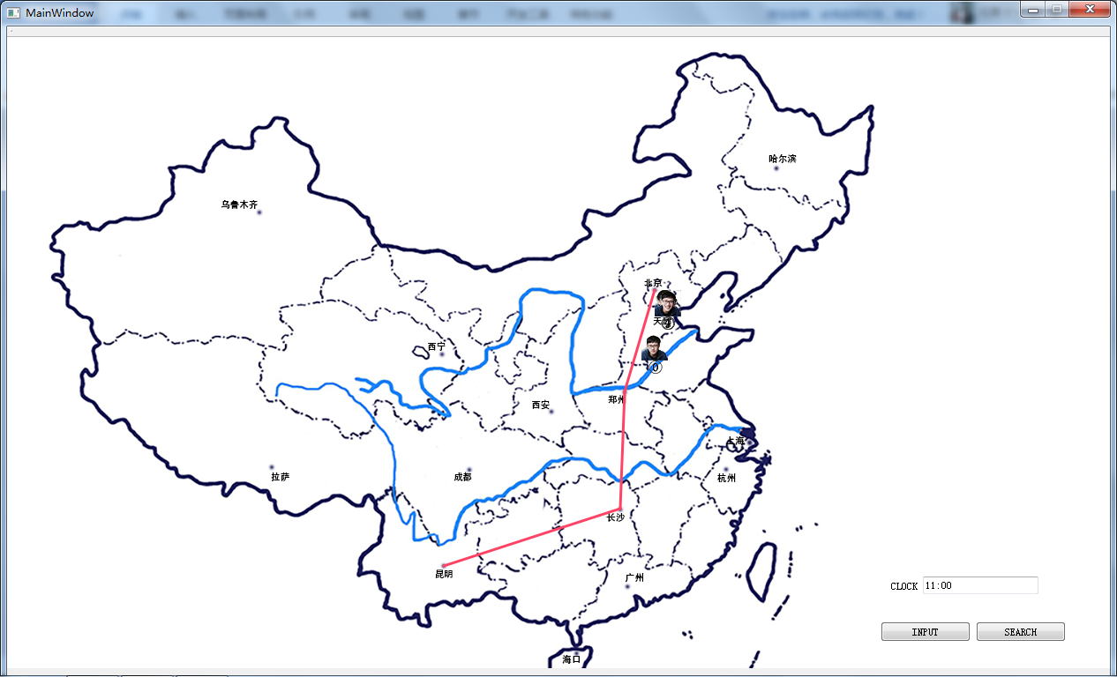

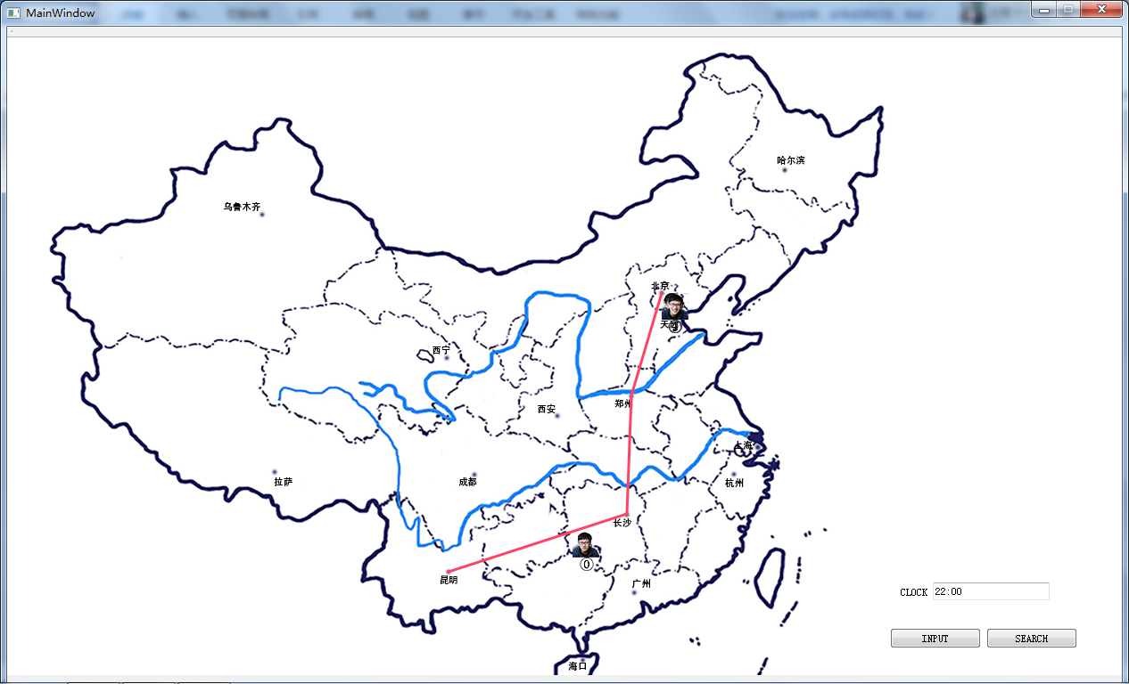

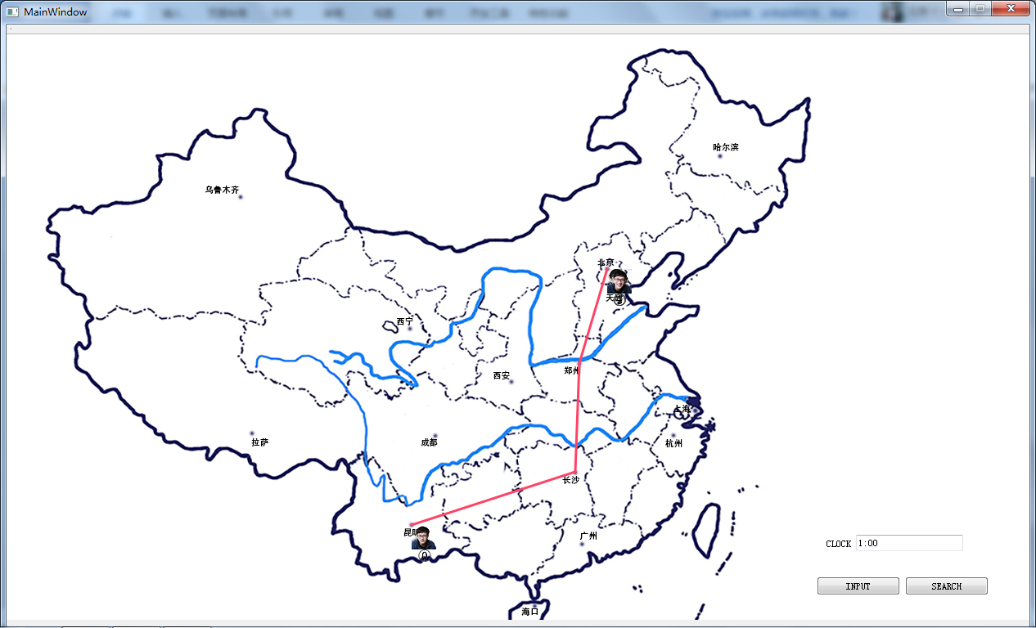

SEARCH TIME 08:00 TOURIST ID 0

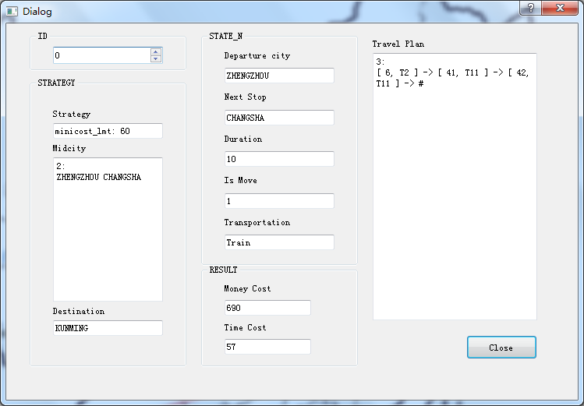

DATA 7（中途到站时更改策略）

SET 00:00 BEIJING





INPUT TIME 06:00 TOURIST ID 0 DESTINATION KUNMING STRATEGY MINICOST MIDCITY EMPTY

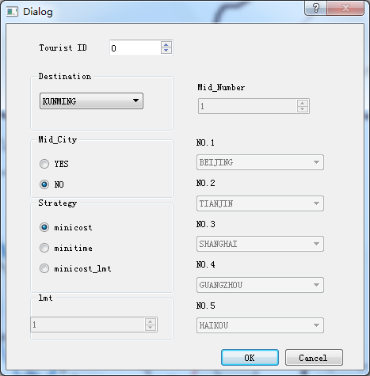

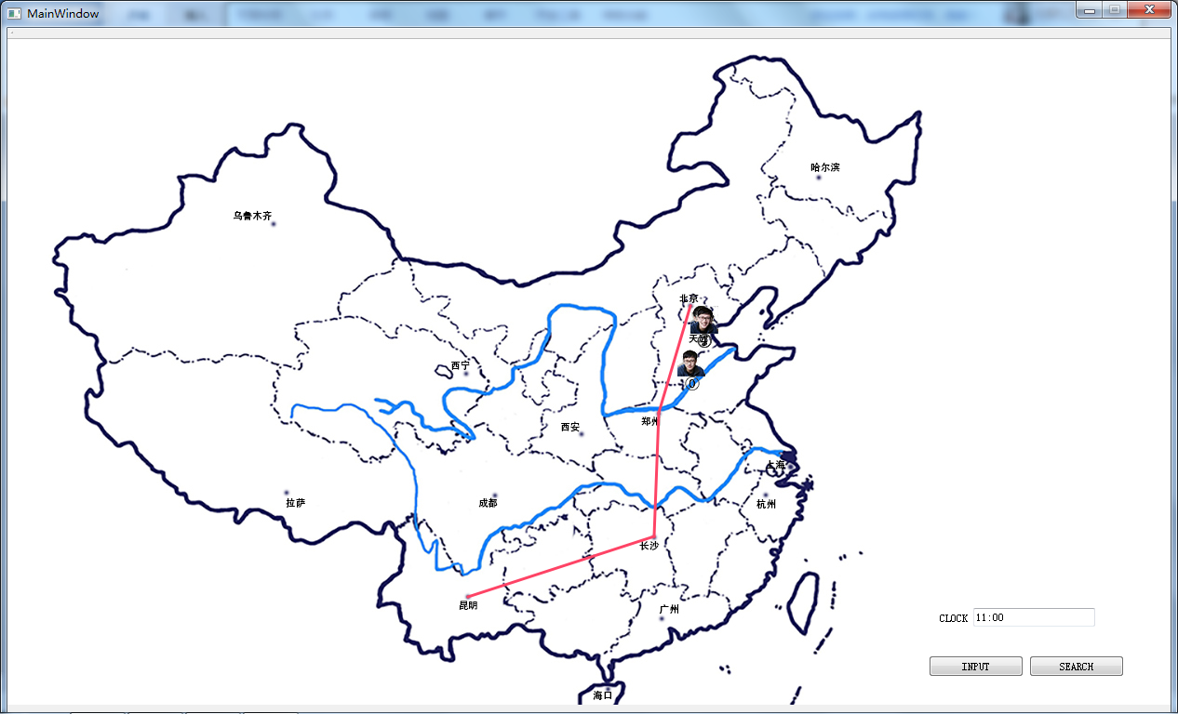

SEARCH TIME 08:00 TOURIST ID 0

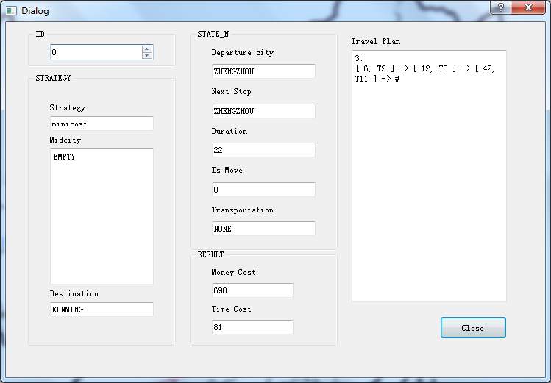

INPUT TIME 04:00 TOURIST ID 0 DESTINATION WULUMUQI STRATEGY MINICOST MIDCITY EMPTY

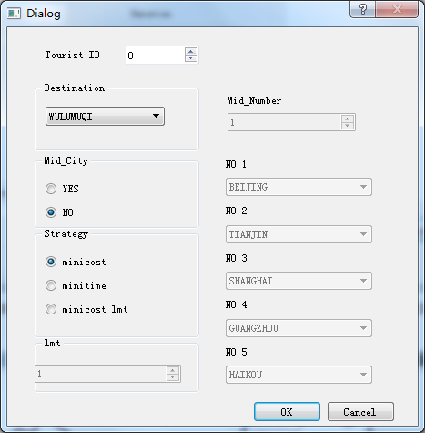

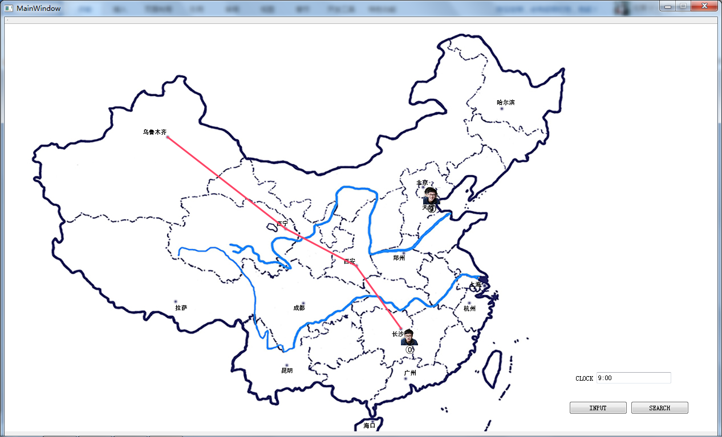

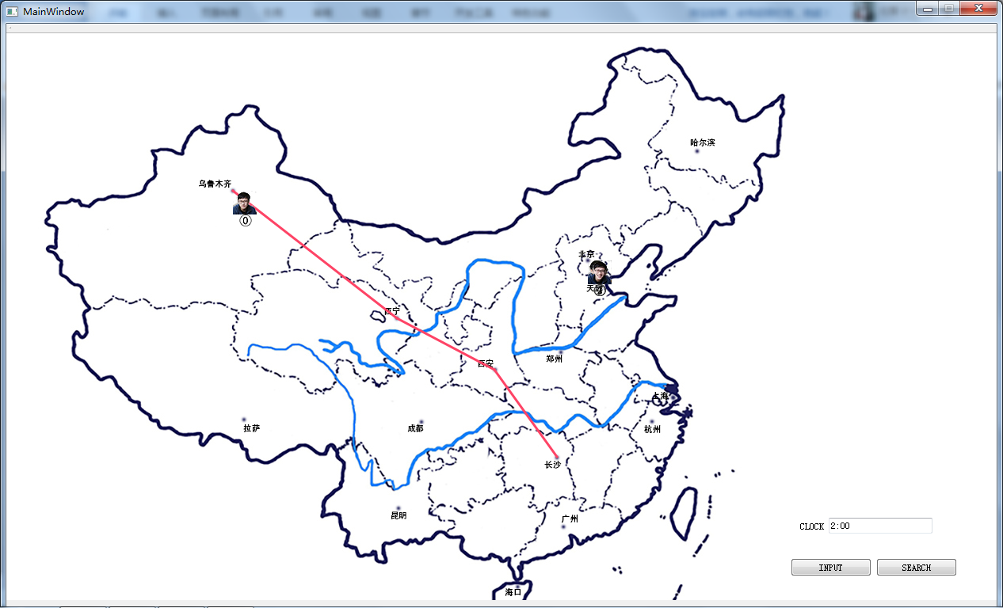

SEARCH TIME 10:00 TOURIST ID 0

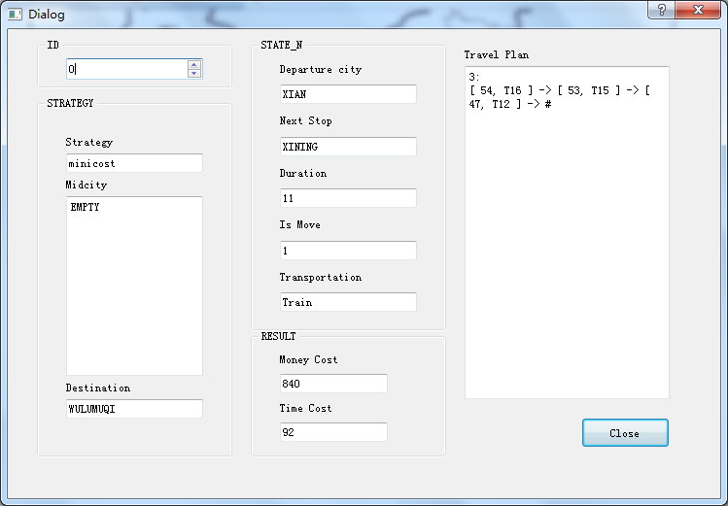

DATA 8（运动中改变旅行策略）

SET 0:00 BEIJING





INPUT TIME 07:00 TOURIST ID 0 DESTINATION HAIKOU STRATEGY MINICOST MIDCITY EMPTY

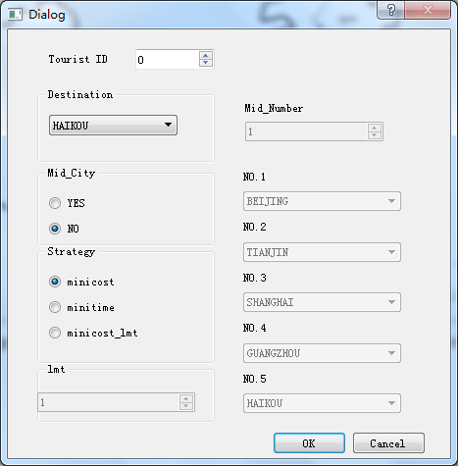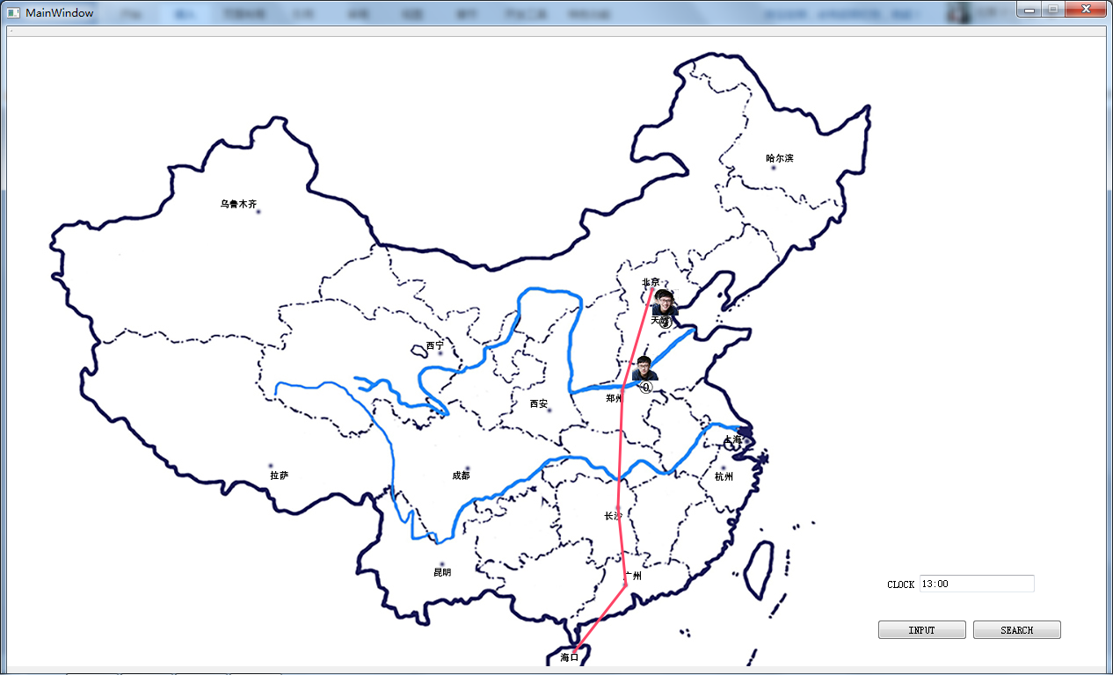

SEARCH TIME 12:00 TOURIST ID 0

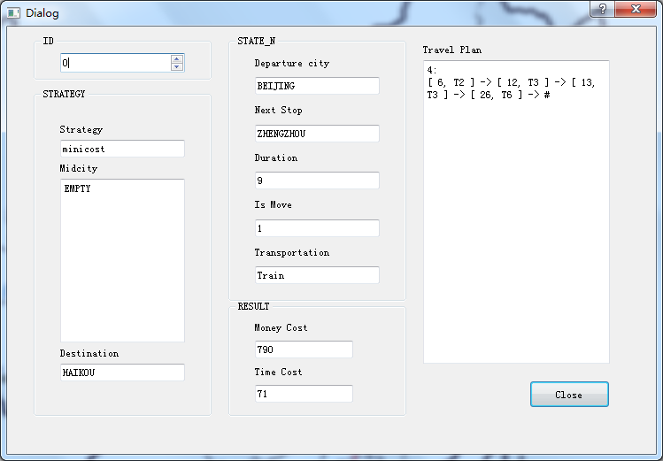

INPUT TIME 16:00 TOURIST ID 0 DESTINATION HAIKOU STRATEGY MINITIME MIDCITY EMPTY

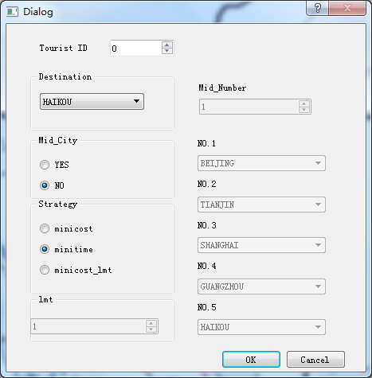

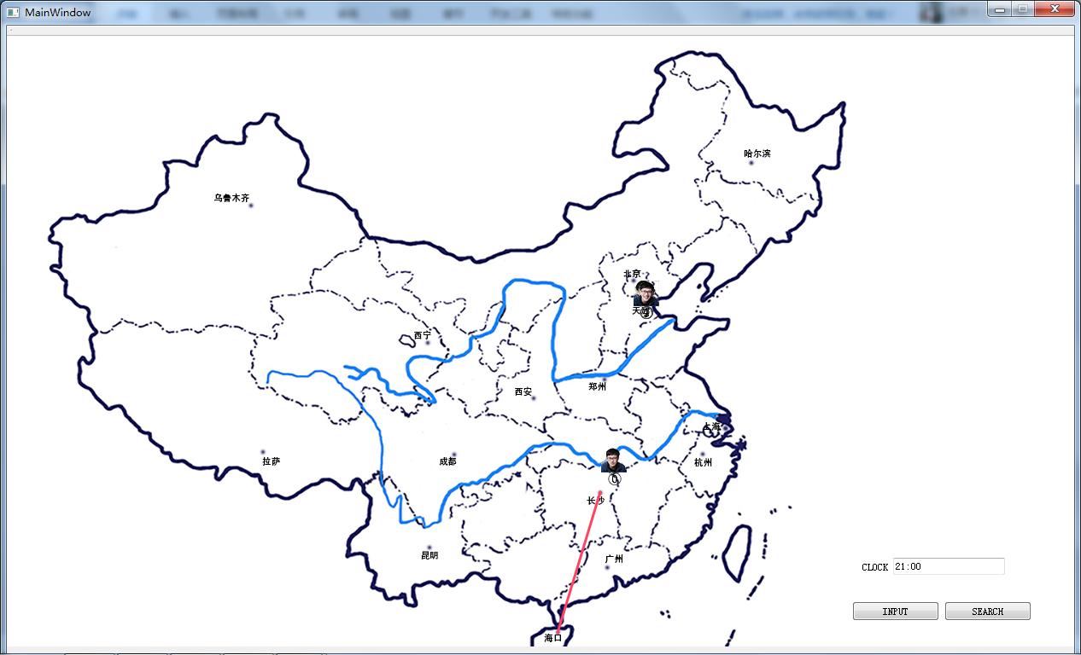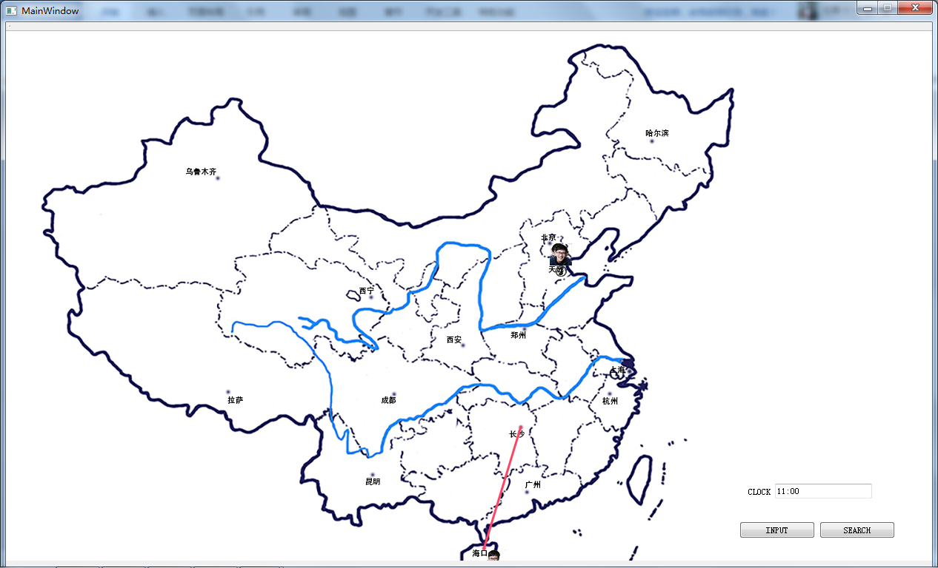

SEARCH TIME 21:00 TOURIST ID 0

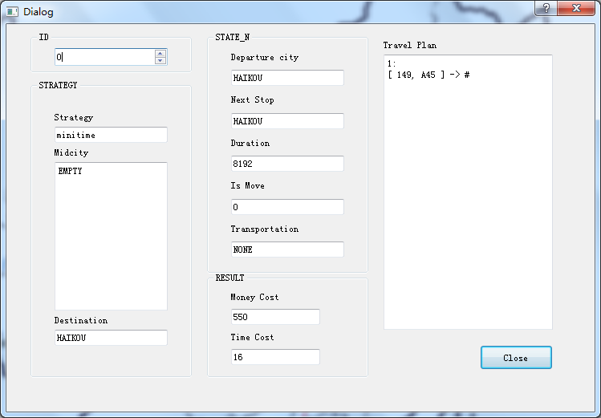

DATA 9（多用户）

SET 0:00 BEIJING





INPUT TIME 04:00 TOURIST ID 0 DESTINATION WULUMUQI STRATEGY MINICOST MIDCITY EMPTY

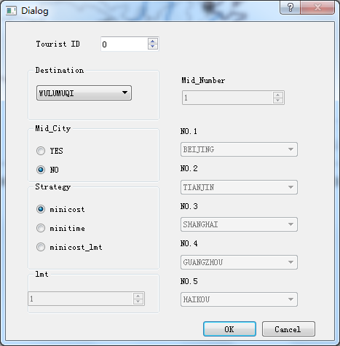

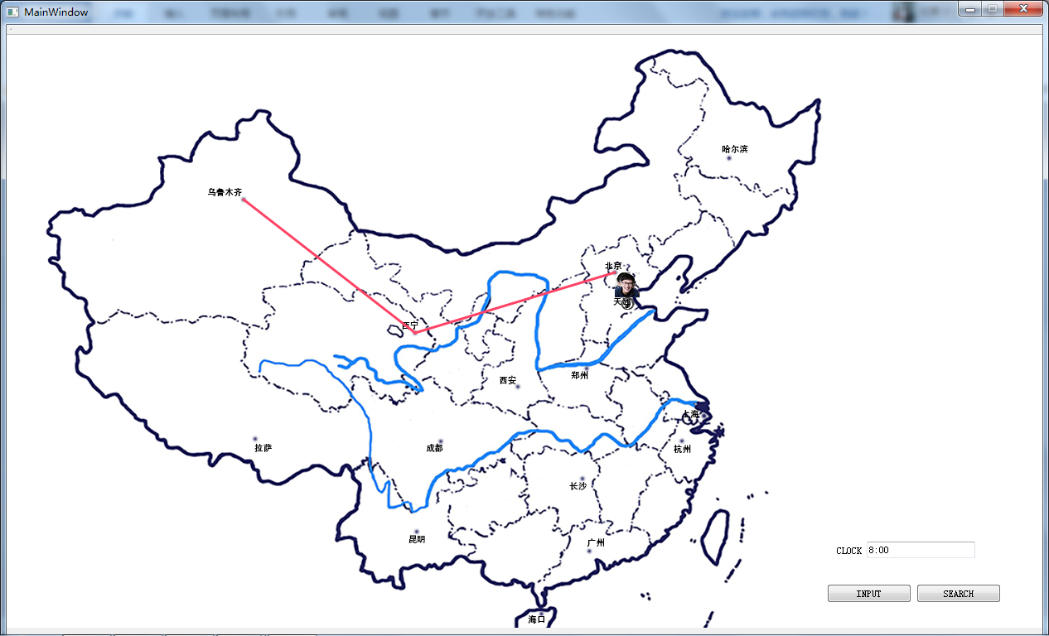

INPUT TIME 17:00 TOURIST ID 1 DESTINATION HAERBIN STRATEGY MINICOST MIDCITY EMPTY

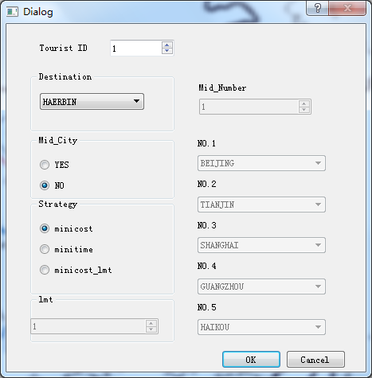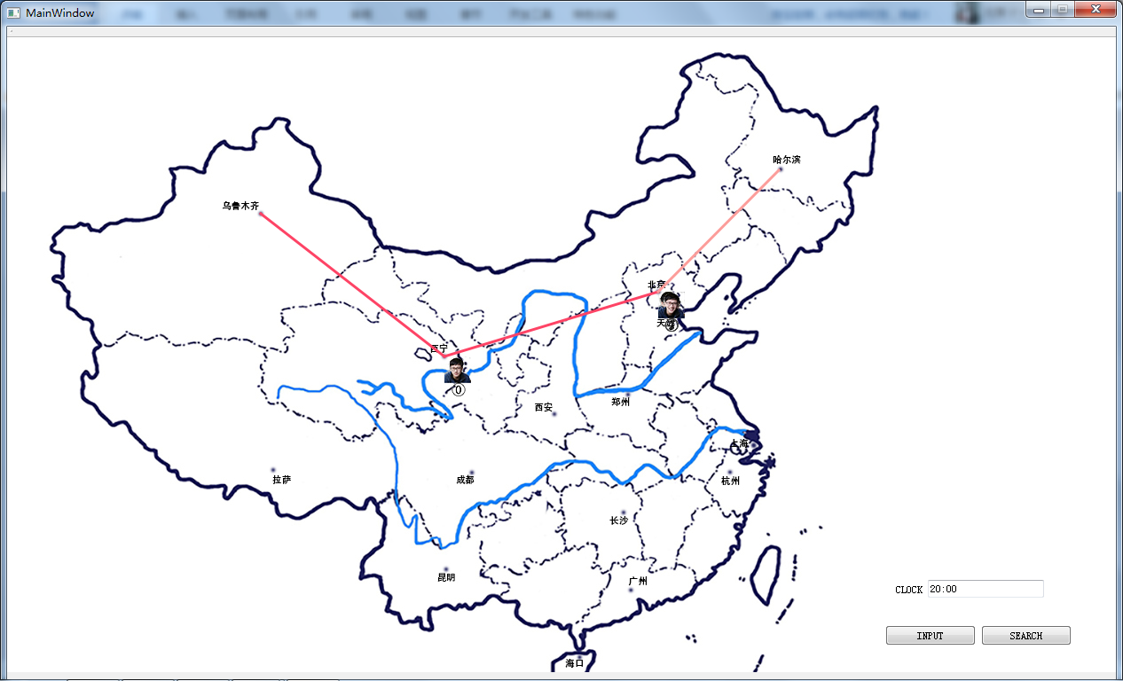

INPUT TIME 09:00 TOURIST ID 2 DESTINATION KUNMING STRATEGY MINICOST MIDCITY EMPTY

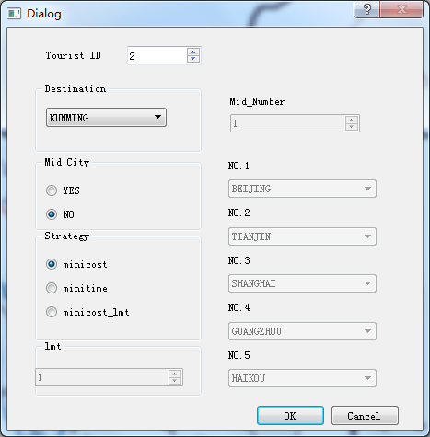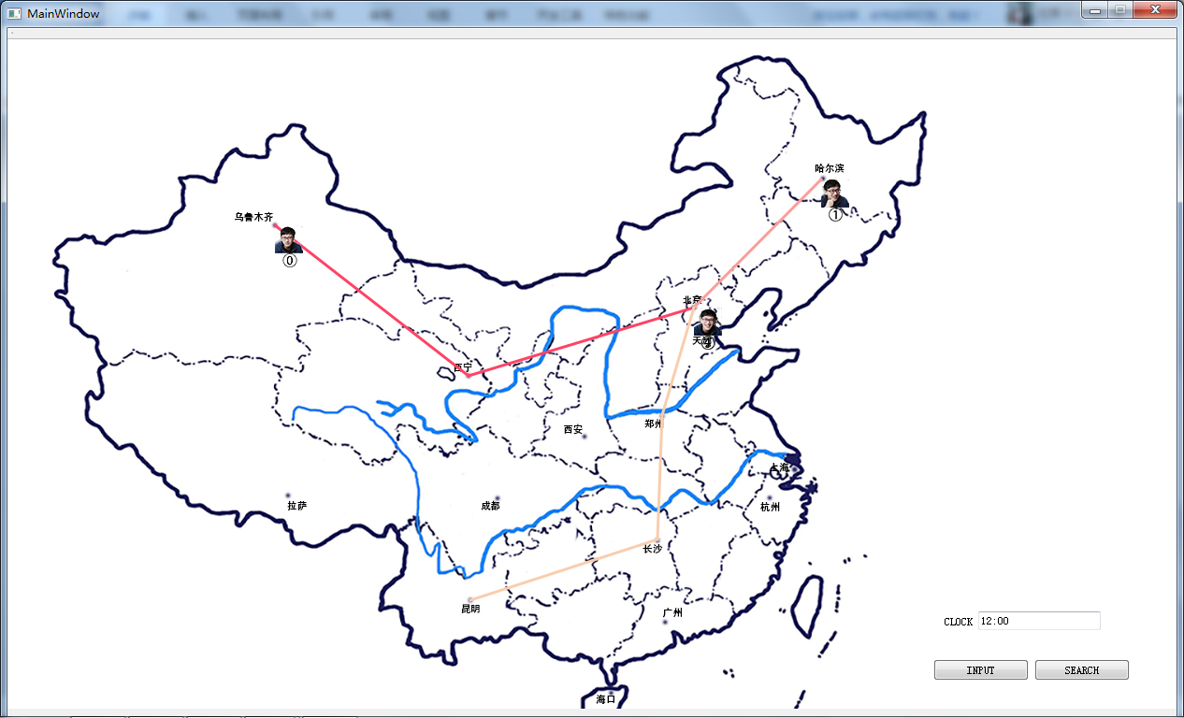

INPUT TIME 03:00 TOURIST ID 3 DESTINATION CHENGDU STRATEGY MINICOST MIDCITY EMPTY

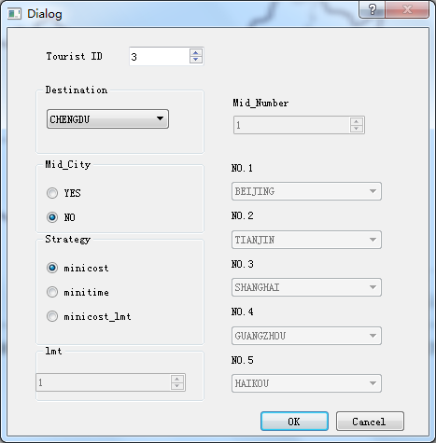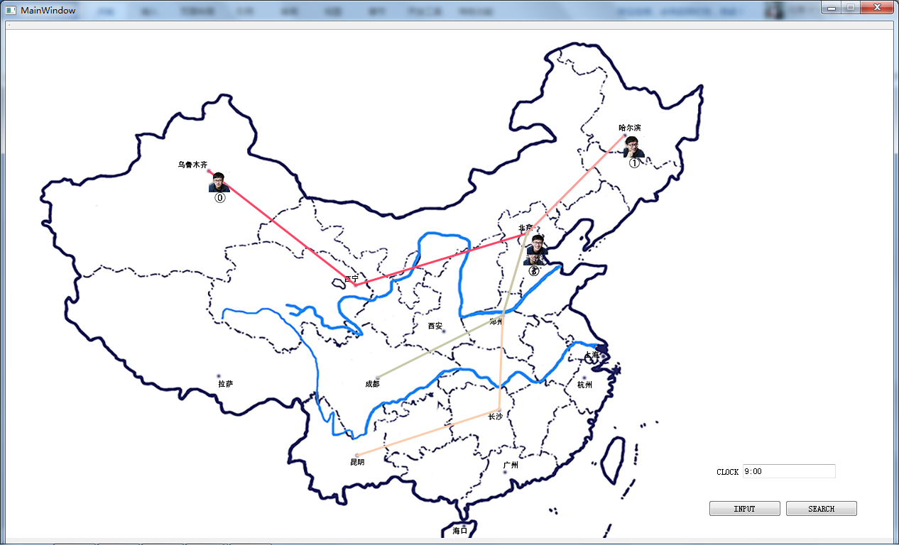

INPUT TIME 19:00 TOURIST ID 4 DESTINATION SHANGHAI STRATEGY MINICOST MIDCITY EMPTY

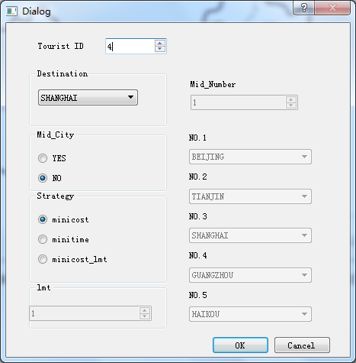

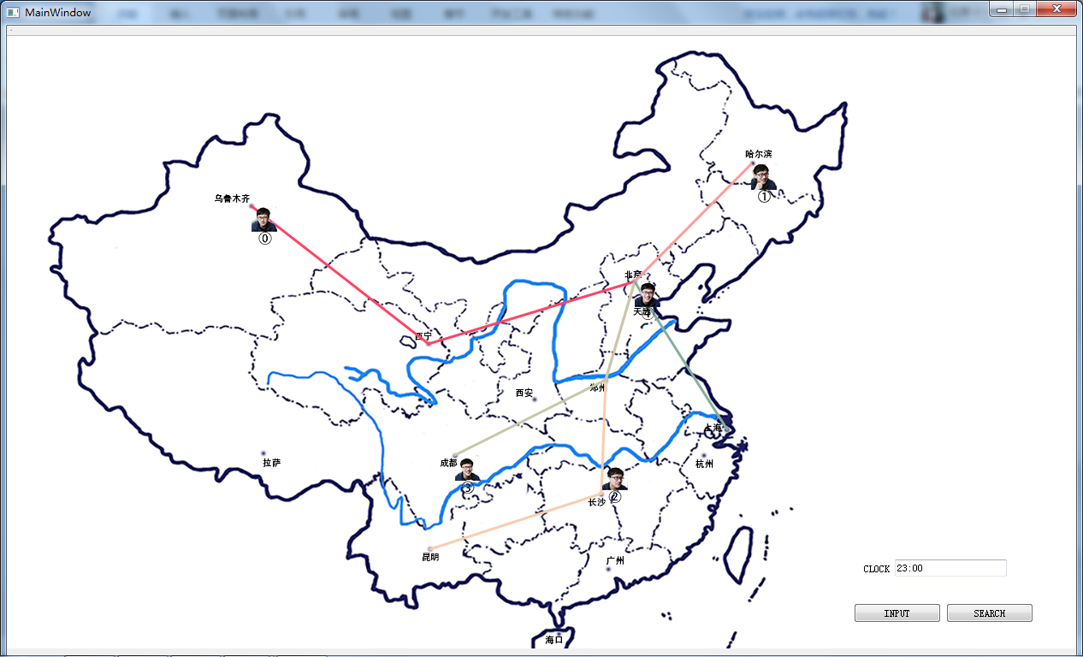

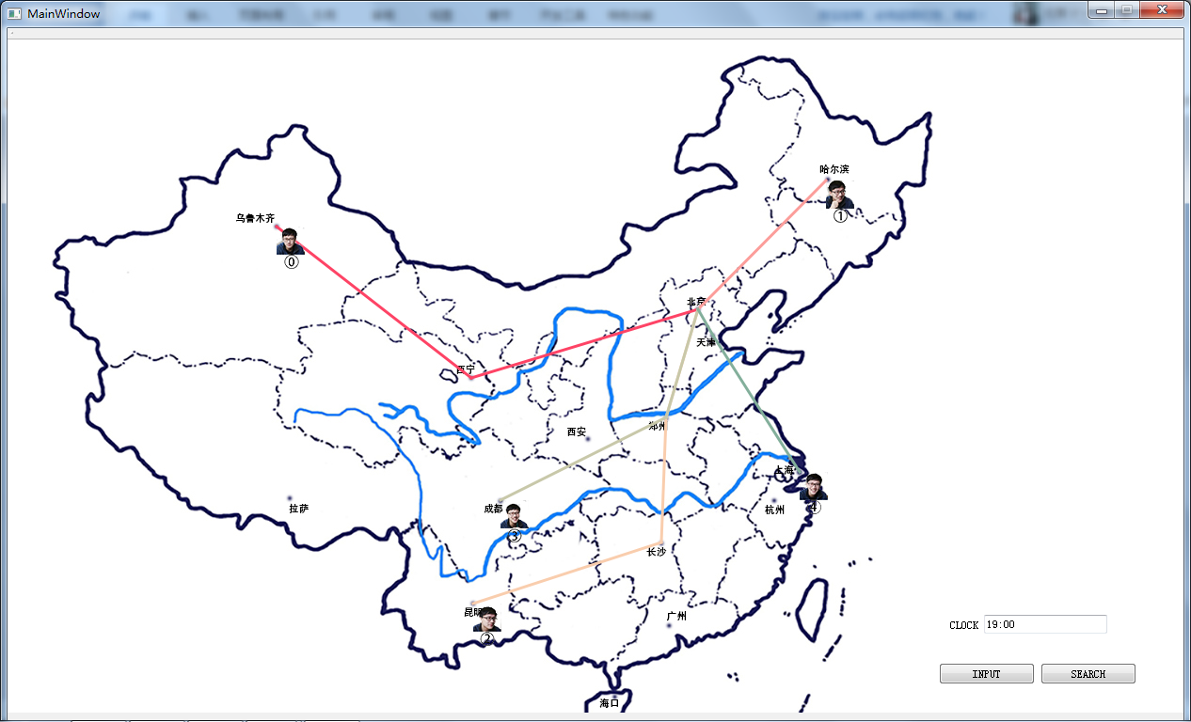

SEARCH TIME 17:00 TOURIST ID 0-4

